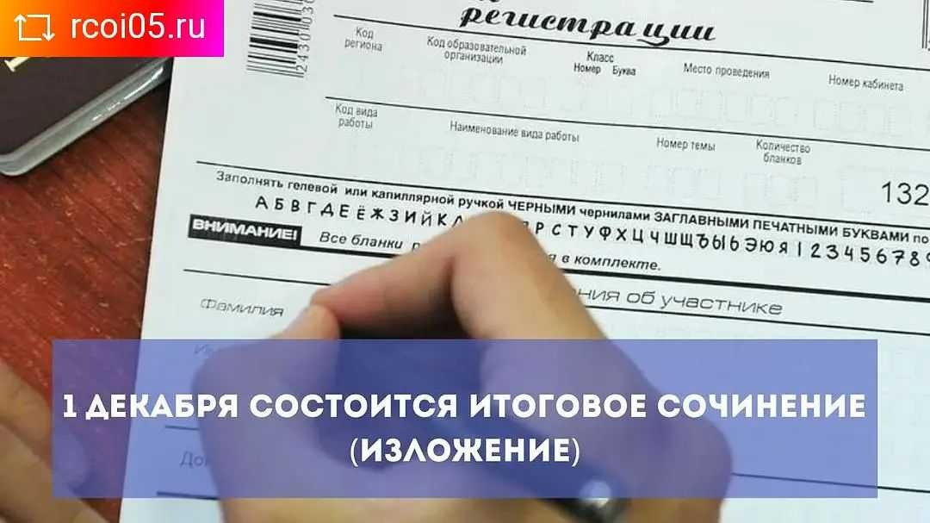

<https://www.instagram.com/p/CWqJeVFIif5/?utm_medium=copy_link>

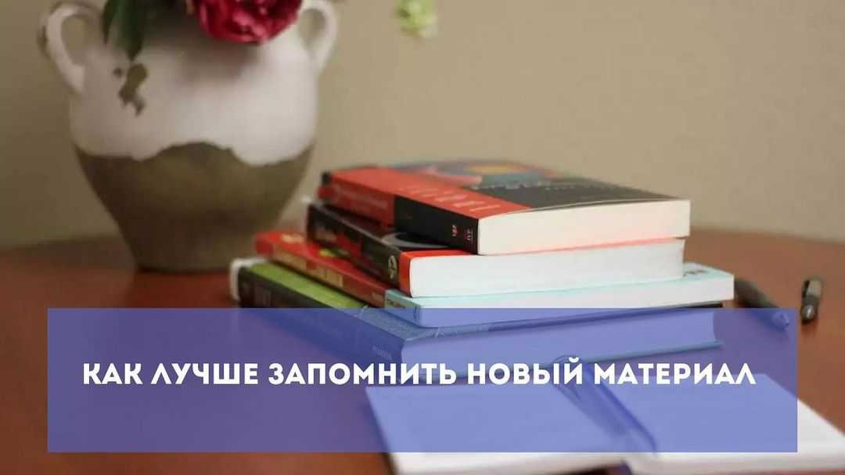

<https://www.instagram.com/p/CWqJeVFIif5/?utm_medium=copy_link>